**Experiment 10 – BJT and MOSFET Switching Characteristics**

**BJT Cut-off Characteristics**

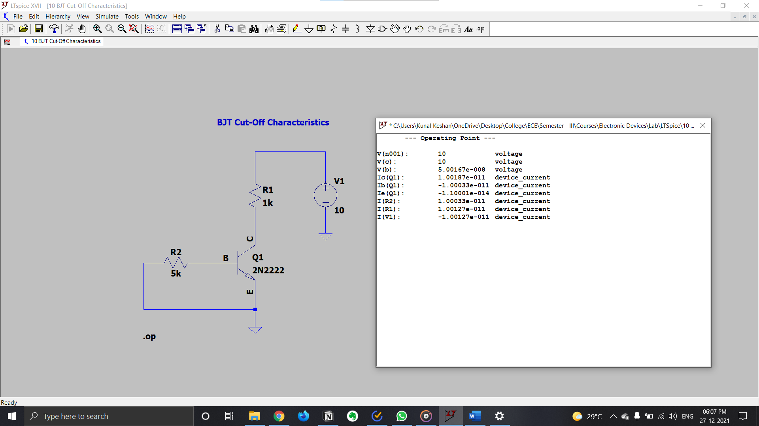

**BJT Saturation Characteristics**

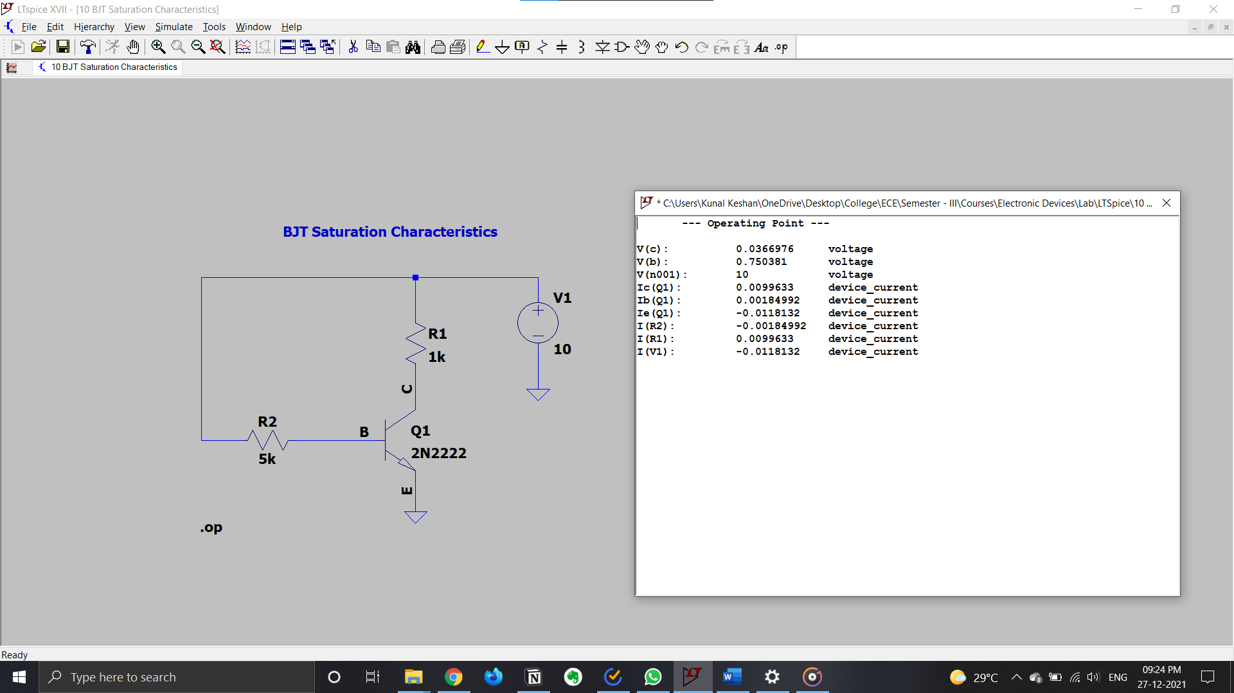

**MOSFET Cut-off Characteristics**

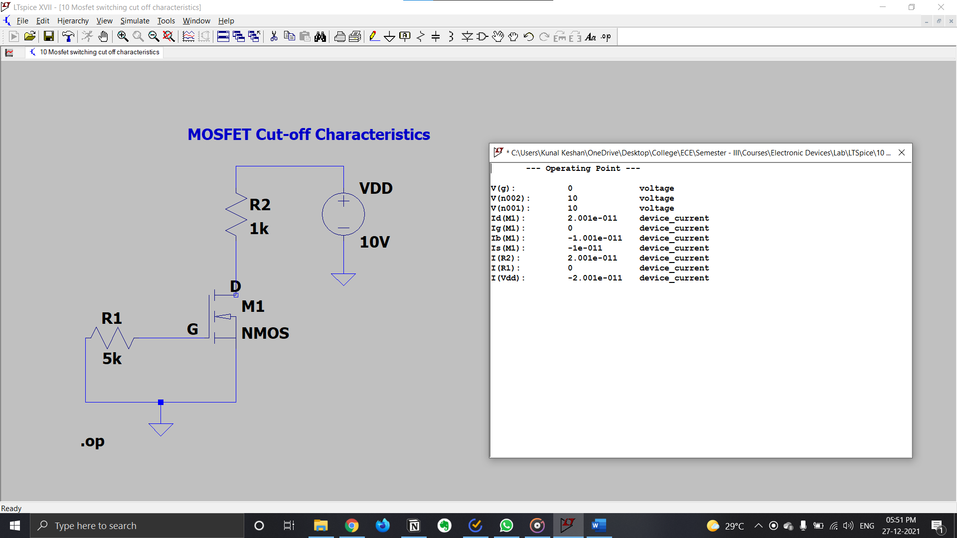

**MOSFET Saturation Characteristics**

